COMFORTABLE 1850 VINTAGE ACCOMMODATION IN HAVANT

In my continuing search for prints produced by the local Victorian artist and engraver William Pink, I came across the engraving shown in Fig. 1. Entitled Thomas Wake’s Cottage, it is dated 1858. Markedly different from William Pink’s usual prints of fine churches and notable buildings, the cottage appears neither notable nor noble, indeed it is pretty well derelict.

I showed the print to friends and received it back with the comment that it was advertising “comfortable accommodation in Havant”. How come? Misled by advertisements, I have stayed in some dives in my time, but surely no-one could be misled into thinking this property could provide “comfortable accommodation”, even back in 1850. So what has the print got to do with accommodation in Havant, what prompted William Pink to engrave this, indeed who was Thomas Wake, and how did he and William come to meet?

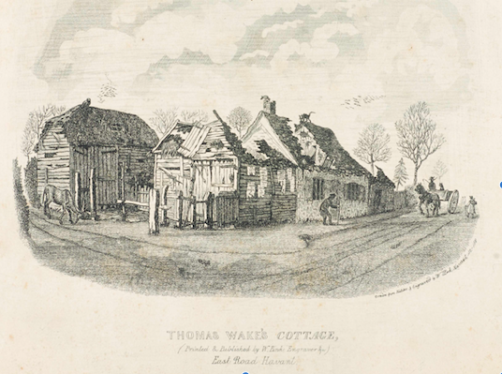
Fig 1

On the Warblington Tithe schedule c. 1840, Thomas Wake is listed as the owner and occupier of the Tithe plot 336. He is also recorded as the occupier of plots (339, 340 & 341), three arable fields owned by Rev. William Norris. The arrangement of these plots and their boundaries, when considered in relation to a modern street map indicates that the Tithe plot 336, on which Thomas Wake’s cottage lies, was situated on the stretch of the Emsworth-Havant Rd at the Havant side of its junction with today’s Wade Court Rd. The print itself shows a horse and trap travelling from Havant along the Emsworth-Havant Rd, and a cottage and outbuildings with a footprint that appears to conform to that of the building shown on plot 336 of the Tithe map.

The 1841 census gives Thomas Wake’s age as 70 and he is living with his wife Anne, also 70. Additionally living with the Wakes is George Clifford age 15, and 3 boys with surname Johnson (Ben 12, Richard 11 and William 9). George Clifford, it would seem, is a grandson since the subsequent censuses of 1851 and 1861 show a widowed daughter, Mary Clifford, living with her father Thomas Wake who by 1851 is a widower himself. In 1841 and 1851, Thomas describes himself, not as a landlord, but as a farmer which confirms the Johnson boys as farmhands rather than paying guests. In 1861 at 90, Thomas Wake is pretty obviously retired although not exactly claiming to be so.

In both the 1841 and 1851 censuses Thomas Wake’s next-door neighbour on the Havant side (Tithe plot 334), separated only by an orchard (Tithe plot 335), is Samuel Tate. Tate died in 1853 and his furniture and effects were auctioned by the local Havant auctioneer Charles Lewis from the deceased’s own residence. From Figs 2 & 3 we can see that this property is Warblington Villa. Incidentally next 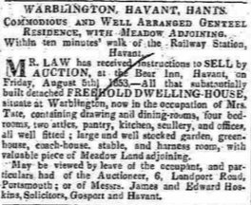 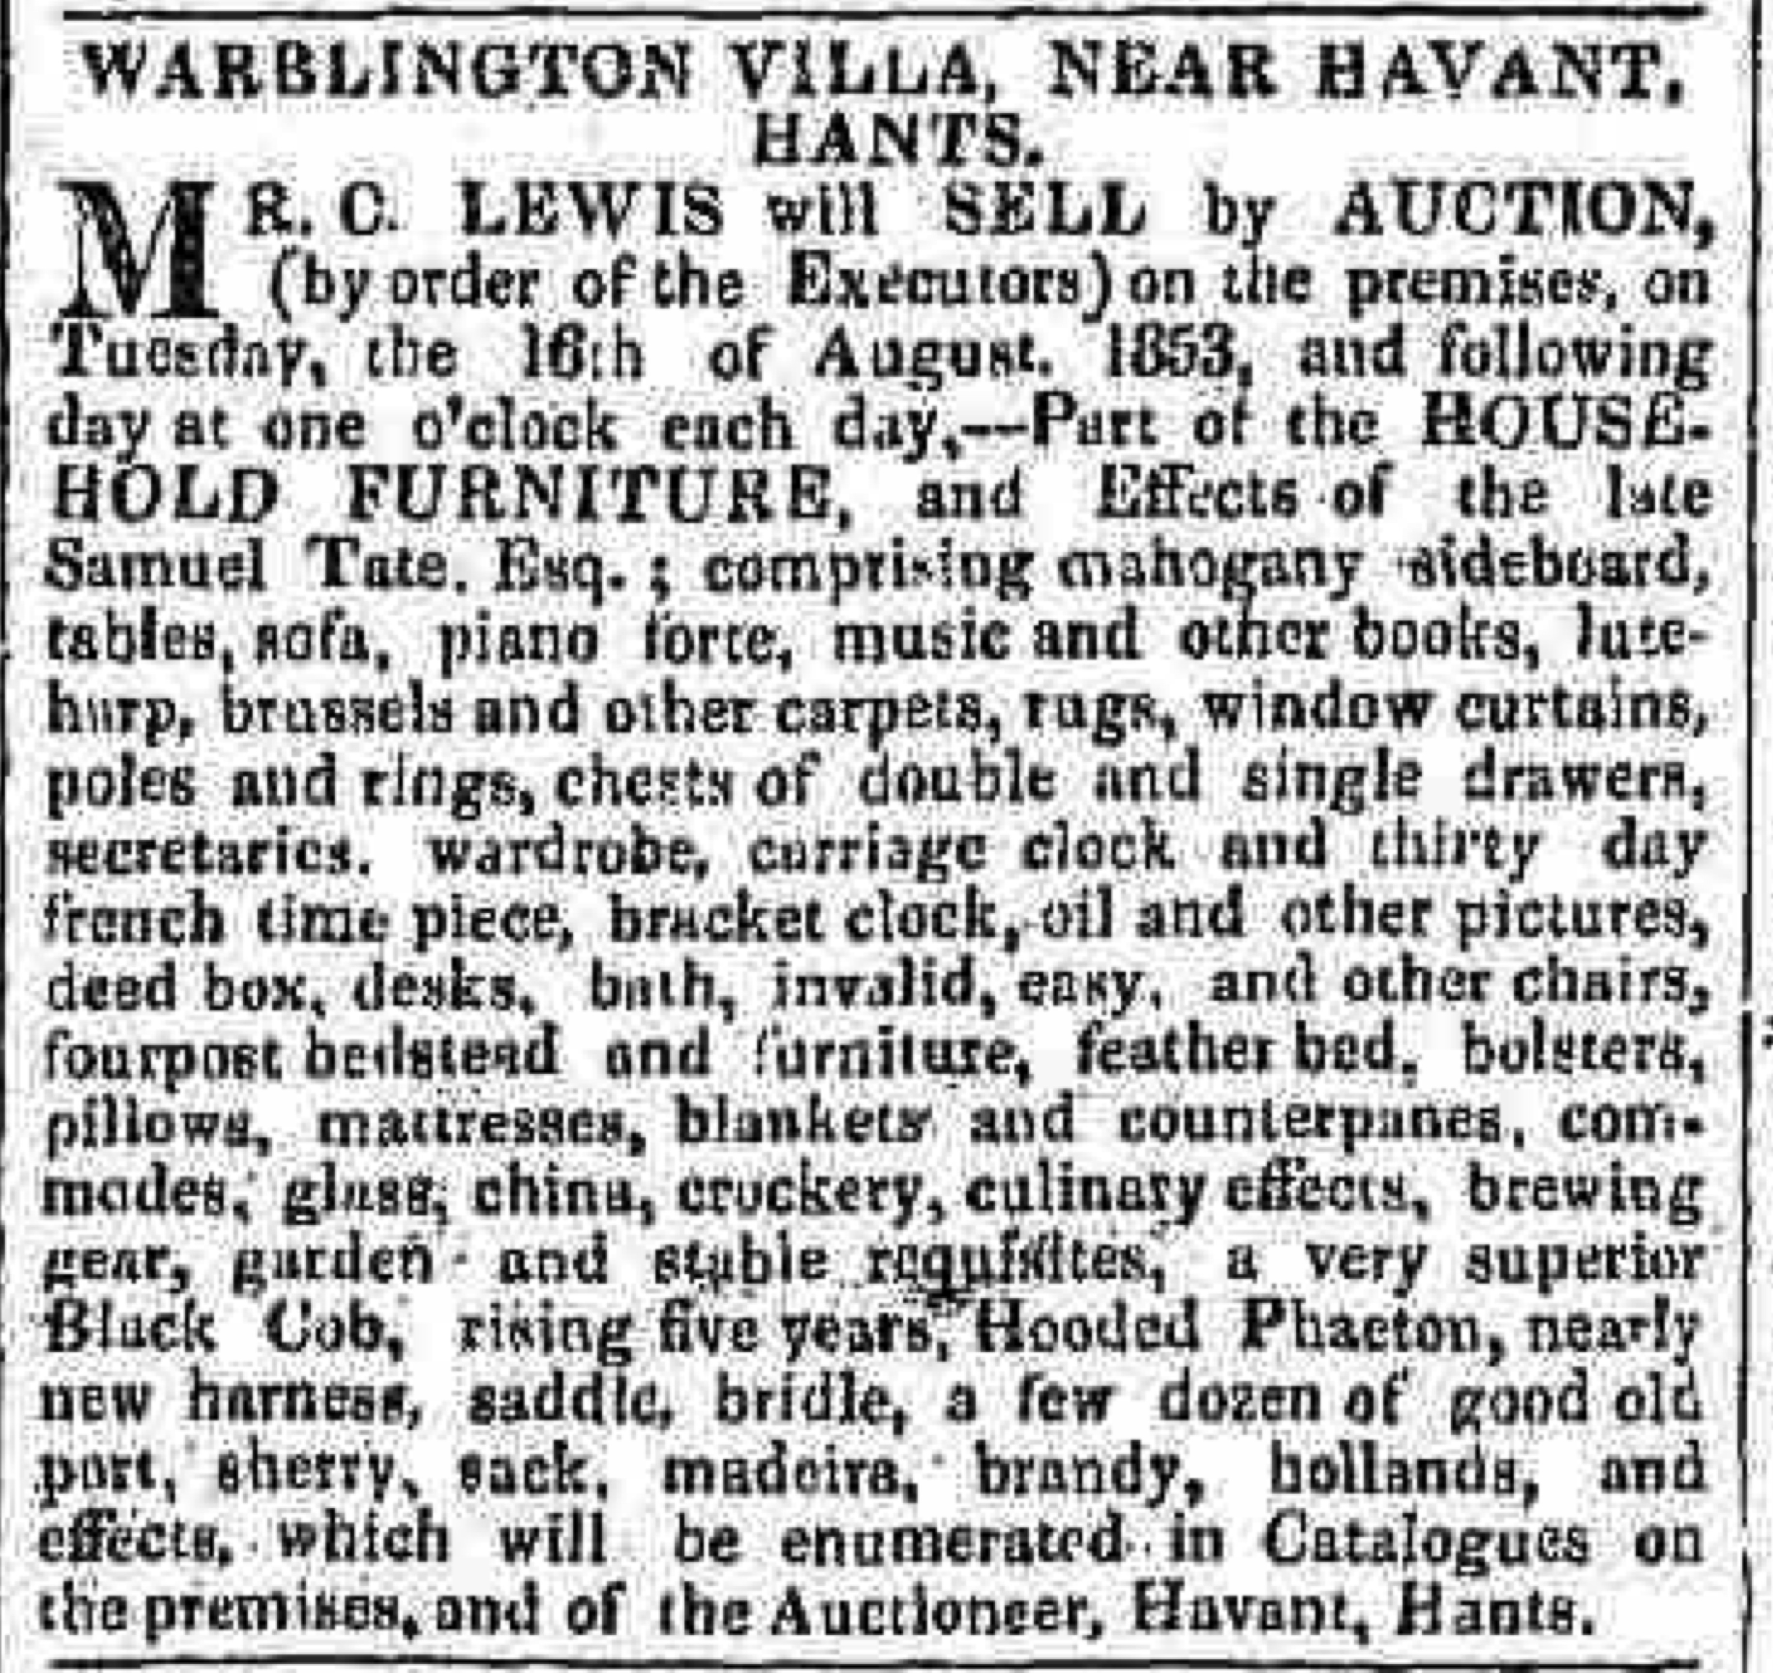
Figs 2 & 3
door but one, again on the Havant side, is a property that Charles Lewis, the maker of this Tithe map and others, rented for four or so years between 1838 and 1843 according to the Tithe record, the 1841 Census and the birth registrations of several of his children. Charles Lewis would thus have been well-acquainted with both Samuel Tate and his wife, making him the natural person to turn to by Mrs Tate at this difficult time. What brings William Pink into these proceedings seems to be the usual result of chance and circumstance.

William Pink married Sarah Jackson in 1856 just one year after the death of their employer Charles Dixon of Stansted Hall, who had made extremely generous provision for them as beneficiaries of his will. By 1861 the census indicates that the “Pinks” are living in Warblington Villa having rented or most probably purchased it sometime during 1856 and 1857. This is exactly the date at which the imprints on William Pink’s engravings change from “W Pink, Emsworth” to “W Pink, Havant”. Thus the Pinks do not appear to have purchased the Villa at the auction advertised in Fig 2. but rather at some slightly later date.

The census information only indicates that Thomas Wake moved from the cottage sometime between 1851 and 1861 so it would not be quite correct to conclude that William Pink makes the acquaintance of Thomas Wake by becoming his next-door neighbour in 1856. If Thomas Wake left the cottage before 1855 then it is possible that they may never have met. What suggests that this is not so, is the destination of Thomas Wake’s relocation.

At the 1861 Census, Thomas Wake is still living with his daughter, Mary Clifford, but they have now moved along the Emsworth – Havant road a little closer to Emsworth. In fact the precise location is next door to Mrs Henville, who in 1851 was the owner/occupier of Hayfield Lodge. Still owner of Hayfield in 1861, but now of advanced years and with minimal retained staff, she seems to have moved out of the Lodge and into some smaller property located within the grounds. My reading of the census information is that Thomas Wake has similar accommodation within the grounds of Hayfield Lodge. This re-arrangement of accommodation at Hayfield Lodge seems to foretell the site’s modern day use as a residential home and I’m beginning to sense that William Pink’s hands are all over this. Only he had all the contacts here, for remember Hayfield Lodge was William’s place of employment, and Mrs Henville his employer, at the time of the previous census of 1851. Back then Hayfield Lodge was also the subject of William Pink’s first engraving, and a print most likely being dedicated to Mrs Henville on his departure from her employ. Knowing both parties well, William is able to resolve their respective accommodation problems with little effort.

This arrangement of living accommodation for Thomas Wake is the closest I have come to associating William Pink with the Hotel and Accommodation trade, hardly justification for the opening remarks of this article. So what did prompt the view that the engraving tells us about fine accommodation in nineteenth century Havant? Well, let’s take a closer look at the engraving, and I mean a closer look! Enlarging the print a little enables one to see that the walls of the cottage retain remnants of posters. Further enlargement enables one to read what the posters were concerned with (see Fig 4). They were advertising “comfortable and airy” lodgings at the Old House at Home, one of Havant’s oldest hostelries and not more than ten minutes walk from the spot that this print depicts.

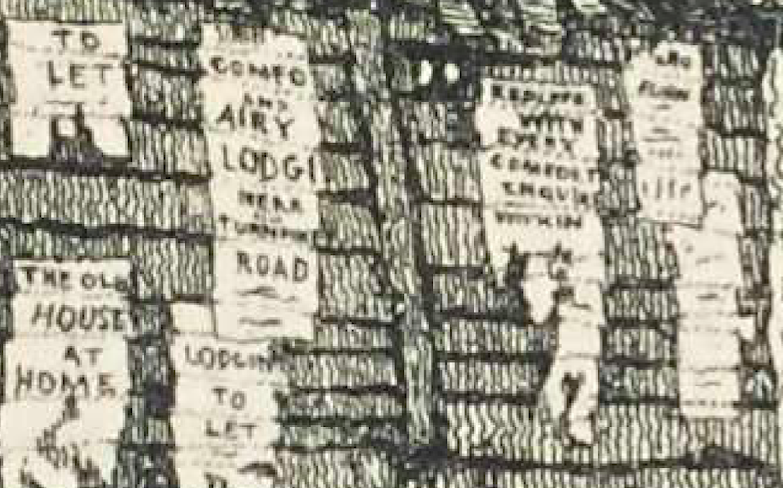
Fig 4

It would seem therefore that the most likely explanation for William Pink’s production of this print is simply that on moving into Warblington Villa in around 1856/7 he discovers a neighbour living in difficult circumstances. The cottage of Thomas Wake has become uninhabitable which, given the state of the roof shown, looks to have been due to disaster rather than gradual decline caused by neglect, although the emaciated state of the donkey roaming the streets on the left side of the print would appear to indicate otherwise. William helps Thomas by arranging more appropriate accommodation, and so the print would appear to be no more than a light-hearted leaving present on Thomas Wake’s moving from the cottage.

Supporting this view are various touches of humour displayed in the print. Observe for example the cat on the chimney pot attempting to catch the birds that are perched there. Also, Thomas Wake must have been a familiar figure in the district given that he lived into his nineties in virtually the same place. Indeed he was 87 at the time of publication of this print of his cottage, so who would bet against the suggestion that it is Thomas Wake himself depicted as the elderly gentleman with walking stick standing outside the dilapidated cottage? And why advertise the Old House at Home? Well maybe, just maybe, it was Thomas’ (and latterly William’s) “local”. Having walked down there for a large slice of his life the print shows a Thomas Wake still sprightly enough to be able to make it, even at 87!

Acknowledgements: I wish to record debts of gratitude to Roy and Sheila Morgan, and Wendy Bright.

A. Clive Pugh

